NMEA GPS Module
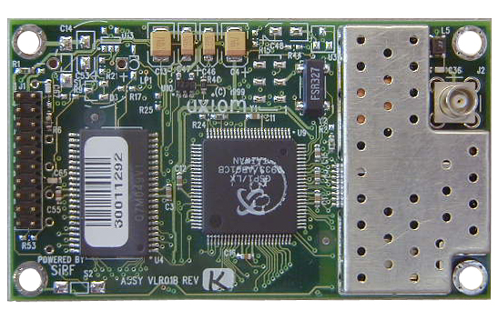
The board that is for sale has a right angle SMA connector for the Active GPS antenna and the connector J1 is bottom feed, the RS-232 Level Shifter installed.
General:
Standard Log Capacity 5000 position and event records in non-volatile memory Optional Log Capacity 25000 position and event records in non-volatile memory Discretes 4 Programmable as Input or Output
Architecture:
Channels 12 simultaneous, all-in-view
Frequency L1 1575.42 MHz
Tracking C/A code & carrier
Flash ROM 256 k x 16
Static RAM 64 k x 16
Processor Speed Hitachi SH-1 at 12.288 MHz
Dynamics:
Altitude -1000 m to 18,000 m
Velocity 500 meters per second
Acceleration 4 g
Jerk 5 meters/second3
Acquisition:
Cold Start < 50 seconds (average)
Warm Start < 40 seconds (current position, time, and almanac)
Hot Start < 8 seconds (current position, time, almanac, and ephemeris)
Snap Start 3.5 seconds (average)
Reacquisition 100 milliseconds
Accuracy:
Position (SA on) 100 meters 2d RMS
Position (SA off) < 25 meter SEP
DGPS 1 to 5 meters
Timing, 1PPS (SA on) < 300 ns, dynamic
Timing, 1PPS (SA off) < 75 ns, dynamic
Receiver Sensitivity -143.5 dB-Hz
Physical:
Dimensions 41.91 x 71.88 x 8.76 mm (1.65 x 2.83 x 0.35 in)
Weight 19.84 g (0.7 oz)
Electrical:
Operating Voltage 5 ± 0.25 Vdc, 50 mVp-p (max)
Power Consumption:
180 mA (continuous on)
Environmental:
Operating Temperatures -40° to + 85° C
Storage Temperatures -55° to + 125° C
Operating Humidity 5% to 95% R.H., Non-condensing, @ + 60° C
Shock 20 g (11 ms saw tooth)
Vibration 4 g

20 pin Connector (J1) Pin out
PIN # | I/O¹ | Signal Name | Description
1 | I | ANT_PWR | DC power to active antenna. Connect 5 or 3 volts, depending on the active antenna being used. Typically 20 to 30ma.
2 | I | VCC_5V | Regulated 5.0VDC +/- 5% input power. 180mA typical.
3 | I | VBAT | Battery backup input. 2V to VCC + 0.5 V. 10uA typical.
4 | I | N/C
5 | I | PBRESN | Manual reset input (ground to reset receiver). Leave floating for normal operation. The minimum pulse width is 10 us resulting in a 140 ms reset signal.
6 | I/O | GPIO1 | General purpose I/O 1
7 | I/O | GPIO2 | General purpose I/O 2
8 | I/O | GPIO3 | General purpose I/O 3
9 | I/O | GPIO4 | General purpose I/O 4
10 | I | GND | Ground
11 | O | TXA | Port A Serial Transmit Data. VCC CMOS levels. GPS messages.
12 | I | RXA | Port A Serial Receive Data. VCC CMOS levels. GPS commands.
13 | I | GND | Ground
14 | O | TXB | Port B Serial Transmit Data. VCC CMOS levels.
15 | I | RXB | Port B Serial Receive Data. VCC CMOS levels. Differential GPS messages.
16 | I | GND | Ground
17 | I | BOOT | Reserved for re-programming flash
18 | I | GND | Ground
19 | O | TIMEMARK | 1PPS (one pulse per second) output. Normally low with 100ms high pulse once every second
20 | I | PWRONOFF | Reserved for future implementation of Push-to-Fix

Summary of Features Installed:
• Power = +5vdc
• Data Connector = Bottom Feed
• RF Connector = Right angle SMA
• ROM & RAM Sizes = 4 Megabits Flash ROM; 1 Megabits RAM
• Super Cap = NOT INSTALLED
• Data = RS-232 Interface
• Software = NMEA @ 4800 baud, 8 N, 1
Minimum connections to make receiver work:
1 | I | ANT_PWR | DC power to active antenna. Connect 5 or 3 volts, depending on the active antenna being used. Typically 20 to 30ma.
2 | I | VCC_5V | Regulated 5.0VDC +/- 5% input power.  180mA typical.
3 | I | VBAT | Battery backup input. 2V to VCC + 0.5 V.  10uA typical.
11 | O | TXA | Port A Serial Transmit Data. VCC CMOS levels.  GPS messages.
12 | I | RXA | Port A Serial Receive Data. VCC CMOS levels.  GPS commands.
13 | I | GND | Ground

